- School Layout and Overview
- Campus Locations & Access Points:
  - Gate-01, Gate-02, Gate-03,Gate 3A, Gate-04, Gate-05, Gate 5A, Gate-06, Gate-07
  - Main Building (Elementary, Middle school, High school, administration), Grade 5 building, KG building, HS gym, Elementary gym, Canteen, Transportation & Uniform store, Art room, swimming pool, Football pitch, Play areas
  - Timings of gates

- Risk Classification Criteria:
- Schools are classified either as High-Risk Entities or Medium Risk Entities based on the following criteria:
  - Nature and Complexity of Operations (including the type of Tasks/ Activities).
  - Number of Employees (excluding contractors).
  - Maximum Number of Other Persons (including students and contractors).
  - Use / Handling of Hazardous Materials (including hazardous wastes).
  - Complexity of buildings and associated structures.
  - Entity Land Area (size of operations).
  - Number of Locations
- AISA is considered as high risk
- Being a High-Risk Entity School means that Health and Safety is a shared responsibility between all the staff, students, contractors, and even visitors.
- During those audits, the audit team may approach you to check if you're aware of the status of your school (Being a High-Risk Entity).

- Communication of OSH Roles & Responsibilities
  - Explains every employee's responsibility to work safely, follow procedures, and report hazard
  - HR communicates the OSH (Occupational Safety and Health) roles, responsibilities, and accountabilities through the following channels:
- Meetings
- Job description
- E-mail
- Security Arrangements
  - Visible Identification: All staff members must wear their Raha International School ID badges visibly at all times while on campus.
  - Visitor & Contractor Control: All visitors, parents, and external contractors must enter through designated security checkpoints (such as Gate 4 or designated entry points). They are required to register, present a valid Emirates ID, and wear a color-coded visitor lanyard while on site.
  - Campus Monitoring: The school campus is monitored 24/7 by CCTV security cameras and on-site guard patrols to maintain compliance with Abu Dhabi safety regulations.

- Traffic Management Plan

Stage | Procedure | Responsibilities | Key Safety Points
A. Morning Drop-Off (7:25 AM – 8:00 AM)
1. Bus Drop-Off | All school buses must use the designated Bus Loop/Yellow Zone. Buses enter the loop, drop students off at the designated curb-side zone, and exit immediately. | School Transport Coordinator, Bus Assistants, Security Staff. | Students must wait for the bus to stop completely before disembarking and should move directly to the nearest staff member/gate. No parents should enter the Bus Loop.
2. Parent Drop-Off | Parents dropping off students must use the designated Parent Lane/Green Zone. This operates as a continuous, one-way Kiss-and-Go system. Parents must not park, exit their vehicles, or block the flow of traffic. | Security Staff, Designated Traffic Marshals (Staff). | Parents must drop off students quickly on the curb-side only. Students must have their bags ready. Vehicles must exit the lane immediately after drop-off.
3. Staff/Visitor Parking | Staff must use the designated Staff Parking/Red Zone after drop-off hours. Visitors must check in at the main gate and be directed to visitor parking. | Security Staff. | All parked vehicles must be parked in marked spaces. No parking in fire lanes or traffic flow areas.
B. Afternoon Pick-Up (2:50 PM – 3:10 PM)
1. Bus Pick-Up | Students assemble at the designated pick-up points and are escorted by staff to the Bus Loop/Yellow Zone. Students board their designated buses promptly. | Bus Assistants, Teachers, Security Staff. | Buses depart strictly according to schedule. Students who miss the bus are taken to a designated safe waiting area for parental collection.
2. Parent Pick-Up | Parents should queue in the Parent Lane/Green Zone as directed by traffic marshals. Students are called and escorted to the waiting vehicle by staff. | Traffic Marshals (Staff), Security Staff. | No student is to cross the Parent Lane unattended. If a vehicle cannot be loaded quickly, the driver must be directed to the Overflow/Purple Parking to collect their child.
3. Pedestrian Exit | Students walking or being collected on foot must use designated and supervised pedestrian gates. | Security Staff, Teachers. | Pedestrians must always remain within designated walkways and crossings.

Parking Zones

Parking is divided into four sections:
- Parent’s parking is in the green colour
- Staff parking is in the red colour
- Bus parking is in the yellow colour
- Overflow parking is in the purple colour

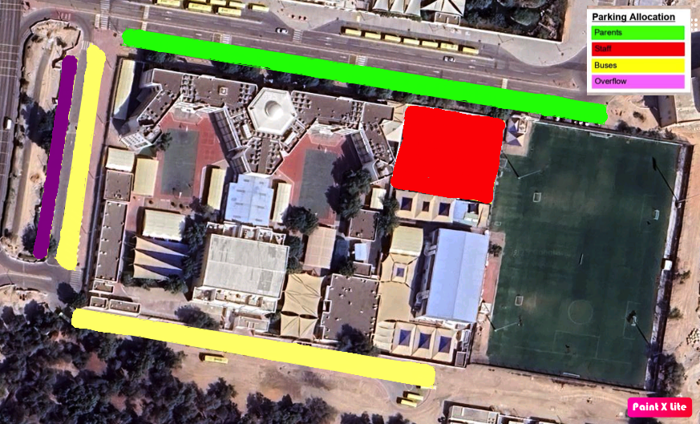

- Gate Timings

AREA | LOCATION | TIME WINDOWS | USERS | SPEED LIMIT
🏗️ MAIN ENTRANCE | Gate 4 | All Day | Faculty | Walking Only
🚌 BUS LOOP | Gate 2 | 7:25 - 8:00: AM  2:50 - 3:10: PM | School Buses Only | 10 km/h
🚗 PARENT DROP-OFF | Gate 4  Gate 3/3A  Gate 5 | 7:25 - 8:00: AM  2:50 - 3:10: PM | Parents + Cycle 3 Students | 15 km/h
🚙 STAFF PARKING | - Gate 5 | All Day | Faculty/Staff Only | 20 km/h
🚶 PEDESTRIAN PATH | Campus Perimeter | All Day | All Students | Walking Only

- General Safety Information
  - Classroom Housekeeping: Corridors, stairwells, and fire exit doors must remain completely unobstructed
  - Trip & Fall Prevention: Trailing cables, loose mats, or damaged flooring must be reported immediately. Wet areas during daily cleaning routines must be clearly demarcated with yellow warning signs.
  - Working at Height: Under no circumstances should teachers stand on student desks, chairs, or spinning office chairs to hang decorations. Staff must use approved step ladders or log a request with the maintenance department.
  - Electrical Safety : Safe use of electrical equipment and reporting damaged equipment
  - Chemical Safety (Where Applicable) : Safe handling, storage, and disposal of hazardous substances

- Work Order Request Procedure
  - Staff should submit all maintenance, repair, furniture setup, moving requests, and other facilities-related services through the Workflow Work Order Request Form. This ensures requests are tracked, assigned to the appropriate team, and completed in a timely manner. Staff should avoid making verbal requests unless it is an emergency.

- Emergency Procedures
  - Fire Detection Systems: The campus facilities are monitored by automated fire alarm systems connected directly to Abu Dhabi Civil Defence via the Hassantuk framework
    - Only use a fire extinguisher:
      - You’re trained to do so
      - You know the classification
      - It is not spreading rapidly
      - You have a clear escape path

  - Evacuation Protocol: Upon hearing a continuous fire alarm siren, teachers must immediately cease instruction, ensure students leave bags behind, and guide the class calmly along the designated route indicated on evacuation map
  - Designated Assembly Points: Classes must proceed directly to their assigned assembly zones clear of the buildings, such as the Football Pitch.
  - Accountability & Roll Call: Once at the assembly point, teachers must take an immediate headcount against their emergency class roster and signal their sector marshal using designated status cards (Green for all present / Red for missing or extra students)
  - Lockdown Announcement: In the event of an external campus threat, a lockdown directive will be broadcast over the PA system. Teachers must instantly pull students from corridors, lock classroom doors, close blinds, turn off lights, instruct students to sit quietly out of sight-lines, and await an official "All Clear" announcement.

- First Aid & Medical Protocols
  - School Clinic Operations: The campus houses a fully equipped school clinic staffed by licensed Department of Health (DoH) medical professionals
  - First aid kits are available :
    - Every building and floor of the school
    - Every school bus
    - Clinic
    - Swimming pool

